Understanding your Retirement

An Online Workshop with
Integrated Financial Solutions, INC.

Workshop Topics:
*Pension and payout options in retirement
*Social Security retirement benefits
*Income from your investments

October | November | December
Tuesday 10/1 | Wednesday 11/4 | Wednesday 12/2
Tuesday 10/6 | Thursday 11/12 | Thursday 12/10
Wednesday 10/14 | Tuesday 11/17 | Tuesday 12/15
Thursday 10/22 | Tuesday 11/24
Tuesday 10/27

All Workshops will be facilitated online at 5:00 PM
RSVP*: Jessica Miller at Jessica.Miller@LPL.com or at 410-480-0007
*Must be a member of MCEA to attend.
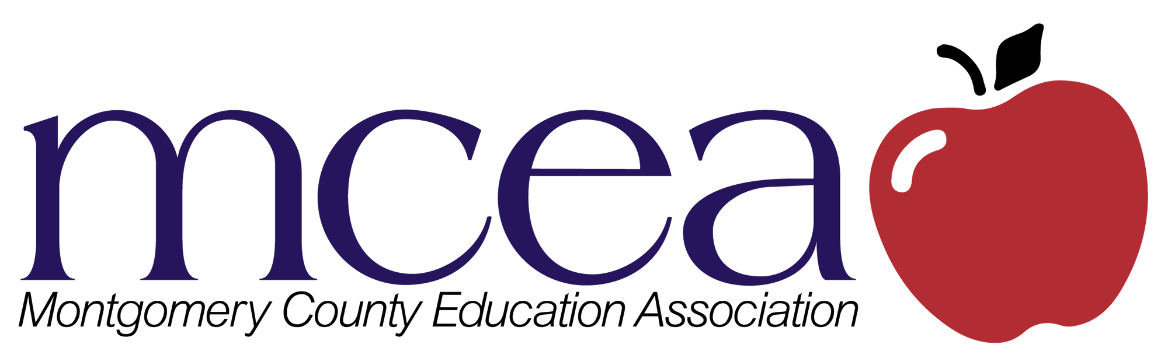

SECURITIES OFFERED THROUGH LPL FINANCIAL, MEMBER FINRA/SIPC LPL Financial is not
affiliated with, nor endorsed by MCEA.

