2019-2020 Councils on Teaching & Learning Meeting Calendar

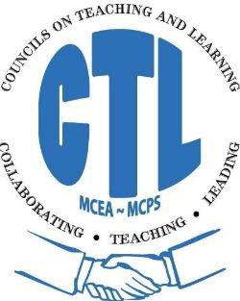

Date | Day of  the Week | Elementary  CTL | Middle School  CTL | High School  CTL
September 24, 2019 | Tuesday | 4:45 – 7:45 pm | 4:00 – 7:00 pm | 3:30 – 6:30 pm
October 22, 2019 | Tuesday | 4:45 – 7:45 pm | 4:00 – 7:00 pm | 3:30 – 6:30 pm
November 20, 2019 | Wednesday | 4:45 -7:45pm | 4:00 -7:00 pm | 3:30 – 6:30 pm
December 10, 2019 | Tuesday | 4:45 -7:45pm | 4:00 – 7:00 pm | 3:30 - 6:30 pm
January 14, 2020 | Tuesday | 4:45 - 7:45 pm | 4:00 – 7:00 pm | 3:30 – 6:30 pm
February 11, 2020 | Tuesday | 4:45- 7:45pm | 4:00 - 7:00 pm | 3:30 - 6:30 pm
March 17, 2020 | Tuesday | 4:45 - 7:45 pm | 4:00 - 7:00 pm | 3:30 - 6:30 pm
April 21, 2020 | Tuesday | 4:45-7:45 pm | 4:00 – 7:00 pm | 3:30 – 6:30
May 12, 2020 | Tuesday | 4:45-7:45pm | 4:00-7:00pm | 3:30-6:30pm

Town Halls will be taking place in November; December will be used as the make-up/snow date

UPDATED 7.12.16

