2018-2019 Councils on Teaching & Learning Meeting Calendar

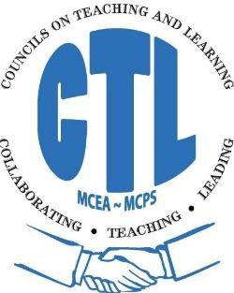

Date | Day of  the Week | Elementary  CTL | Middle School  CTL | High School  CTL
September 26, 2018 | Wednesday | 4:45 – 7:45 pm | 4:00 – 7:00 pm | 3:30 – 6:30 pm
October 16, 2018 | Tuesday | 4:45 – 7:45 pm | 4:00 – 7:00 pm | 3:30 – 6:30 pm
November 28, 2018 | Wednesday | 4:45 -7:45pm | 4:00 -7:00 pm | 3:30 – 6:30 pm
December 11, 2018 | Tuesday | 4:45 -7:45pm | 4:00 – 7:00 pm | 3:30 - 6:30 pm
January 16, 2019 | Wednesday | 4:45 - 7:45 pm | 4:00 – 7:00 pm | 3:30 – 6:30 pm
February 20, 2019 | Wednesday | 4:45- 7:45pm | 4:00 - 7:00 pm | 3:30 - 6:30 pm
March 20, 2019 | Wednesday | 4:45 - 7:45 pm | 4:00 - 7:00 pm | 3:30 - 6:30 pm
April 9, 2019 | Tuesday | 4:45-7:45 pm | 4:00 – 7:00 pm | 3:30 – 6:30
May 15, 2019 | Wednesday | 4:45-7:45pm | 4:00-7:00pm | 3:30-6:30pm
June 17, 2019 | Monday | 8:00 – 3:00 pm | 8:00-3:00pm | 8:00 – 3:00 pm

Town Halls will be taking place in January; February will be used as the make-up/snow date

UPDATED 7.12.16

